How to Use the Template System
Contents
1. Get started 1
1.1. Synchronize SharePoint on local computer 1
1.2. Setup environment 1

Initial setup environment

Synchronize SharePoint on local computer
https://steria.sharepoint.com/sites/Qregulate/QDocuments/Forms/AllItems.aspx
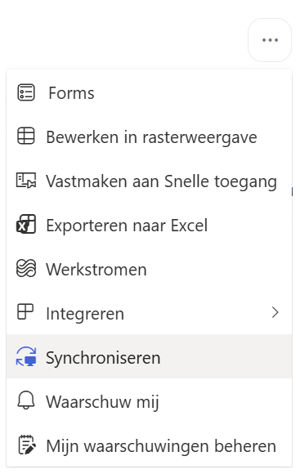

Setup environment
This template system supports a dev and prod environment. As a regular user (non-developer) follow this one-time instruction.
In Windows Explorer, open the folder "C:\Users\%your username%\Sopra Steria\Q-Regulate - Q-Documents\Master Template\SSG-MC". Double click on "junction.bat".
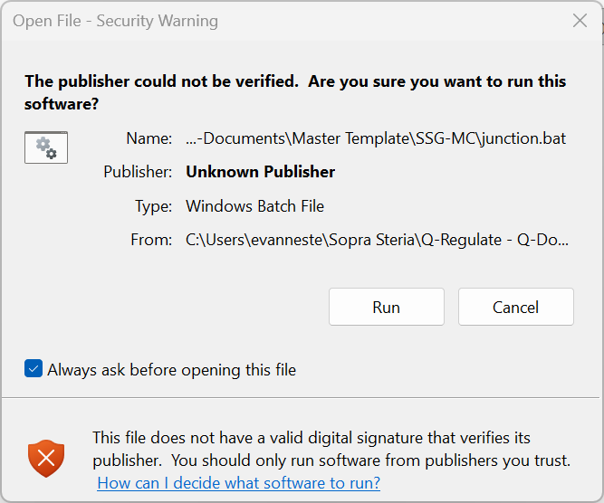
Figure 1: a security warning may pop up. Press "Run" to continue
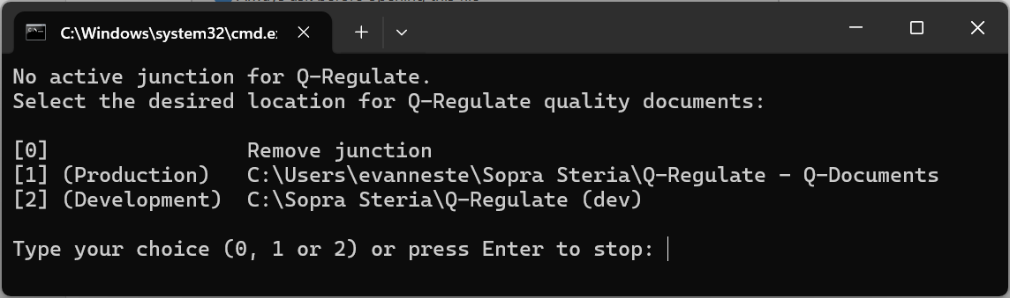
Figure 2: enter "1" as your choice
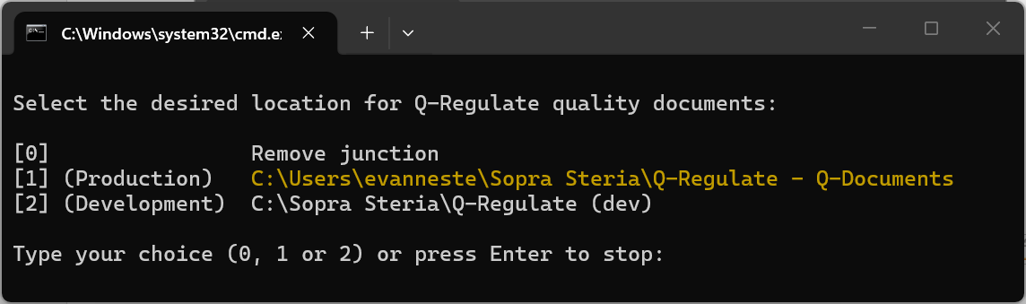
Figure 3: successful setting the working path will be shown in yellow. Contact template system owner when an error occurs.

Get started

General remarks
Microsoft Word (referred to as Word in the remainder of the document), starts from a template to create a document. By default, "normal.dotx" is used, where the 't' in the file extension '.dotx' stands for template.
A document is initialised from this template, but it must be saved before it is on file. A file created from a template is saved as '.docx'.
In Word, a template typically contains a set of styles to help the author to layout the document.

Open Microsoft Word

